***“*He is Worth Exalting *… in the Church”***

**A. An Example from Ephesus**

**1) Forgetting your first Love**

All the Right Ingredients is no guarantee …

**2) How can we be a Christ Exalting Church?**

a) Remember where we have fallen

Exodus 20:2

b) Repent

Acts 19:17-20

c) Do Works you did at first

Love for Jesus eclipsing all else

**B. An Example from Jerusalem**

**1) The emphasis on “Us”**

John 17:22-23

Acts 2:42-47

**2) The Greatest Joy … is a Joy Shared**

*“The believer is in spiritual danger if he allows himself to go for any length of time without tasting the love of Christ and savoring the felt comforts of the Savior’s presence. When Christ ceases to fill the heart with satisfaction, our souls will go in silent search of other lovers.”* Maurice Roberts, *The Thought of God*, p.57-58

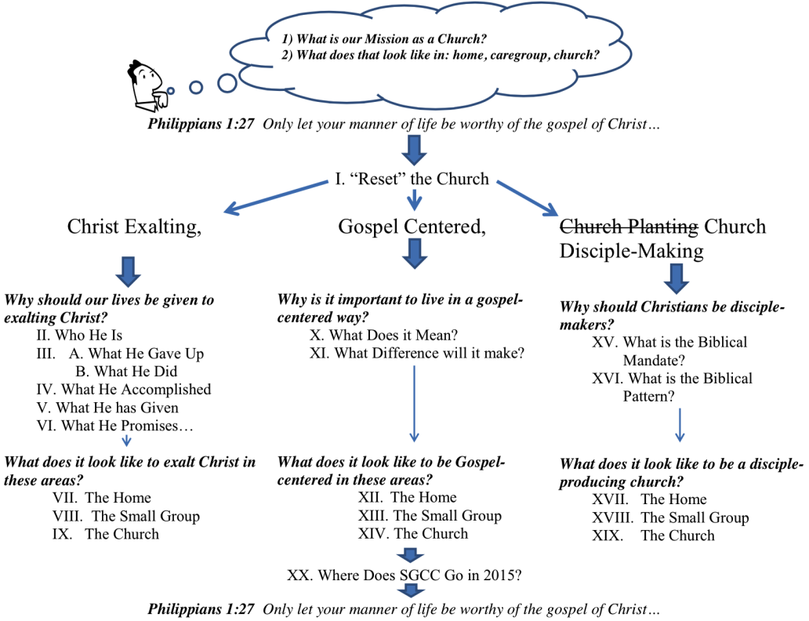**Family Meeting Agenda: *Together in 15’***

* **Drama**
* **Short** **Communication:**
  + Bruce Chick - *Together* in 15’
  + Eph 4:29
* ***Together* in Missions:** 
  + Andrew Kellam [Deacon of Missions]
  + State of the Union – SGCC Missions in 2015
* ***Together* on Finances:** 
  + Chris Uliana [Deacon of Finance]
  + State of the Union – SGCC in 2014 & Plans for 2015
* ***Together* on Child Safety:** 
  + Spencer Vaughn [Ministry Safe Seminar & Training]
* ***Together* in 15’**
* **Calendar Update 2015** [select happenings]
  + Saturday Seminars – “SSS” [Second Saturday Seminar]
  + Discipleship Groups – Women/Men
  + Sunday Night – PMC [Prayer/Ministry/Communion]
  + Wild Card Week – [Couples Nights/Evangelism Outreaches 4x]
  + Halloween Outreach
* **Update on Pastoral Internship**
* **Brief Members Only Portion**