**“Giving: The Christian *Way”***

**Mark 12:41-44**

**I) Abide: *Every member possessing a thriving prayer life and a rich bible devotional life***

**II) Follow: *Every member a Spirit-led worshipper and practitioner***

**III) Go: *Every member participating in a short term mission trip & thereafter actively supporting local and extra local mission endeavors***

**IV) Tell: *Every member sharing the gospel 1x each year.***

**V) Serve: *Every member serving on a ministry team at SGCC.***

**VI) Give: *Every member generously & cheerfully laying up treasure in heaven.***

**I. Widow & 2 Copper Coins** Mark 12:41-44

**A) OT Temple**

Deuteronomy 12:10-11

**B) A Way to live**

Jesus was demonstrating how He wanted His disciples to ____________.

1) Not the Amount but the __________ of Giving

2) Gift Represented Total ________________ to God

3) Life of Faith

**II. Why Should I be a Giver?**

**A)** **God is a Giver / It images God**

Joshua 1:11; 1 Kings 4:29; Exodus 1:21; Deuteronomy 9:10; 1 Corinthians 4:7

God gave His ______! John 3:16

**B) God is Worth it**

Matthew 10:42

**C) It Expresses Faith**

**D) You lay up Treasure in Heaven**

***Is it wrong to be motivated by reward?*** Philippians 4:17

**Reward is _________ Idea!**

a) Way you live [Luke 6:35; Matthew 6:6, 19-20]

b) Way you give [Matthew 6:3-4]

**E) You Experience Joy**

**F) You Become More Like Christ**

** Recognizing God’s Grace makes you ________ to be a giver

2 Corinthians 9:7 2 Corinthians 9:15

**Quotes**

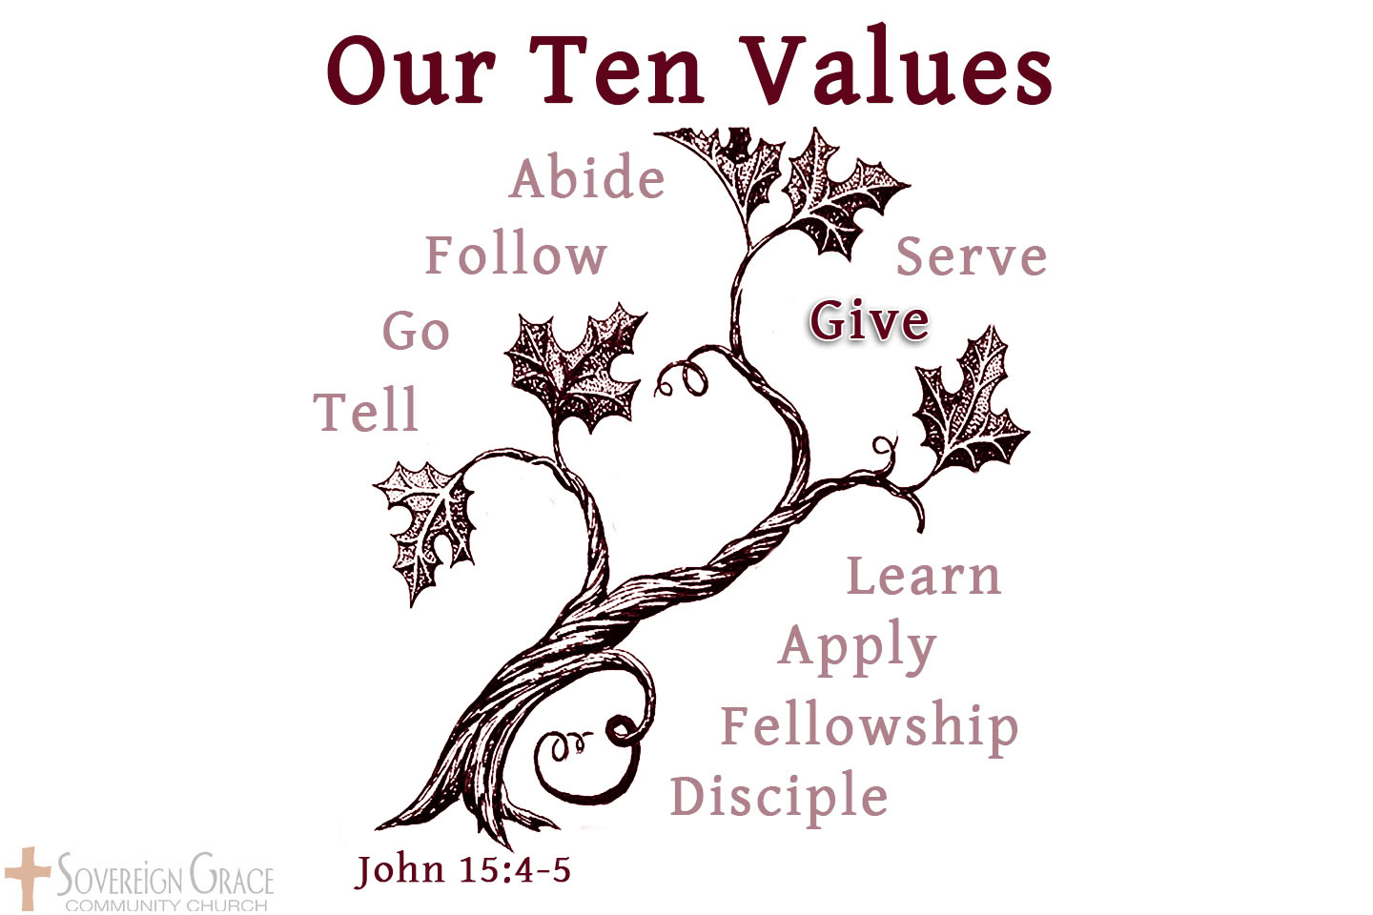

*“I have tried to keep things in my hands and lost them all, but what I have given into God's hands I still possess.”* Martin Luther

*“Gaze upon Christ long enough, and you’ll become more of a giver. Give long enough, and you’ll become more like Christ.”* Randy Alcorn